**Password Manager**

A Project Report

Submitted for the partial fulfillment for the award of the degree of

**Bachelor of Technology (Information Technology) 2024-25**

Submitted by:-

**Tanshi Khandelwal**

**Richa Kumari**

Under the supervision of

**Tushar Sharm****a**

**Abstract**

In today's digital age, the security of online accounts and personal information is of utmost importance. However, managing multiple passwords for various services often leads to either weak, easily guessable passwords or the tendency to reuse passwords across different platforms. To address this critical issue, we propose the development of a comprehensive Password Manager application.

This Password Manager is designed to securely store, manage, and retrieve passwords for users. It leverages advanced encryption algorithms to ensure the highest level of security for stored credentials. Users can generate strong, unique passwords for each of their accounts and store them within the application. Additionally, the application offers a user-friendly interface that allows users to organize and access their passwords with ease.

By offering a secure and efficient solution for password management, this application aims to enhance the overall digital security and convenience for users, thereby reducing the risks associated with weak or reused passwords.

**Acknowledgement**

We would like to express our heartfelt gratitude to everyone who contributed to the development and success of this Password Manager project.

We extend our deepest thanks to our project mentor, Tushar Sharma, for her invaluable guidance throughout the course of this project. Her keen interest in our work, constructive advice, and constant motivation were instrumental in the successful completion of this project.

We also sincerely thank our project coordinators for their unwavering support and encouragement. Their assistance and dedication played a significant role in bringing this project to fruition.

Lastly, we express our appreciation to all those who helped, directly or indirectly, and played a role in the development and completion of this project.

**Table of Contents**

1. **Introduction**
   1. Purpose
   2. Scope
   3. Glossary
   4. References
2. **System Overview**
3. **Requirement Analysis**
   1. Functional Requirements
   2. Non-Functional Requirements
   3. Software Requirements
   4. Hardware Requirements
4. **System Design**
   1. Use Case Diagram
5. **Database Design**
   1. Class Diagram
   2. ER Diagram
6. **Testing**
   1. Overview of testing methodologies used for validation and verification.
7. **Results**
   1. Screenshots of application interfaces.
   2. Outputs and database content examples.
8. **Future Scope**
   1. Enhancements for the project.
9. **Timeframe and Description**
   1. Timeframe
   2. Contribution Description
10. **Wireframe**
11. **Conclusion**
12. **References**

#### 1. Introduction

**1.1 Purpose**

The purpose of the Password Manager application is to provide a secure and centralized system for users to manage their passwords efficiently. By leveraging advanced encryption and a user-friendly interface, the application aims to enhance digital security and streamline password management for individuals and organizations.

**1.2 Scope**

In today's digital world, managing multiple passwords for various accounts can be challenging and risky. This Password Manager provides a reliable solution to securely store, generate, and manage passwords. Users can log in to the platform, generate strong passwords, and store them in an encrypted format. The application also supports automatic login to user accounts, making it convenient and secure for users to access their credentials.

**1.3 Glossary**

* **Password Manager:** Software application designed to store and manage passwords.
* **Encryption:** The process of converting information or data into a code to prevent unauthorized access.
* **User Authentication:** The process of verifying the identity of a user.

### 1.4 References

* **Node.js Documentation:** Node.js Documentation
* **MySQL Documentation:** MySQL Documentation
* **Express.js Documentation:** Express.js Documentation
* **Node.js Tutorial:** W3Schools Node.js Tutorial
* **MySQL Tutorial:** Getting Started with MySQL
* **Express.js Tutorial:** Introduction to Express.js - W3Schools

#### 2. System Overview

The Password Manager is designed to be accessible and user-friendly, catering to the needs of users who require a secure and efficient way to manage their passwords. The platform is available on multiple devices, ensuring users can access their passwords anytime, anywhere. The application provides strong password generation, secure storage, and automatic login features, all aimed at enhancing digital security.

#### 3. Requirement Analysis

**3.1 Functional Requirements**

* **Password Storage:** Users can securely store their passwords using advanced encryption techniques.
* **Password Generation:** Provides strong password generation to enhance security.
* **Automatic Login:** Facilitates automatic login to user accounts, saving time and enhancing convenience.
* **User Authentication:** Ensures secure access to the platform through user authentication.

**3.2 Non-Functional Requirements**

* **Availability:** High uptime with minimal downtime for maintenance.
* **Security:** Protect user data and ensure secure communications.
* **Reliability:** Maintain a low rate of errors or crashes.
* **Portability:** Run on various devices like desktops, laptops, tablets, and smart phones.
* **Maintainability:** Easy to maintain and update with clear documentation.

**3.3 Software Requirements**

* **Programming Languages:** JavaScript, Node.js
* **Frameworks:** Express.js
* **Database Management System:** MySQL
* **Front-end Development:** HTML5, CSS3, Bootstrap, Js
* **Browser for Testing:** Google Chrome
* **IDE:** Visual Studio Code
* **Operating System:** Windows 8 and higher

**3.4 Hardware Requirements**

* **Developer Side Requirements:**
  + RAM: Minimum 1 GB or above
  + CPU: 2.0GHz or higher speed
  + Hard Disk: 10-20GB storage capacity
* **Server End Requirements:**
  + RAM: Minimum 2 GB or above
  + CPU: 2.0GHz or higher speed
  + Hard Disk: 10GB or above storage capacity
* **Client Side Requirements:**
  + Network Access Device: Laptops.

#### 4. System Design

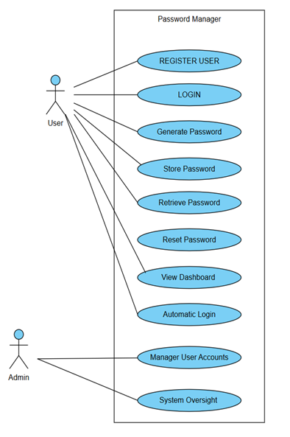**4.1 Use Case Diagram**

#### 5. Database Design

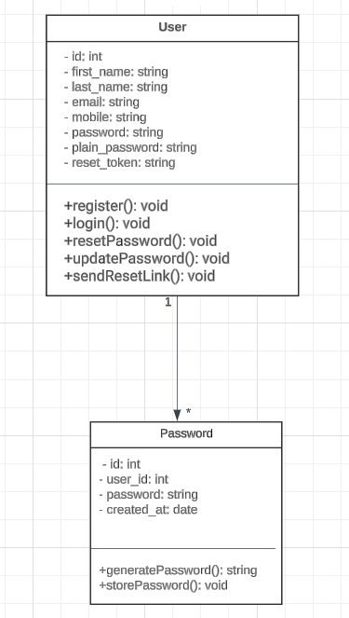**5.1 Class Diagram**

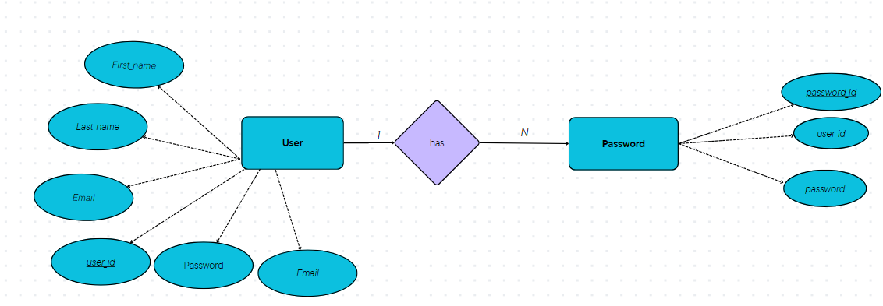**5.2 ER Diagram**

#### 6. Testing

**6.1 Overview of testing methodologies used for validation and verification**

* Unit Testing
* Integration Testing
* System Testing
* User Acceptance Testing

#### 7. Wireframe

**7.1 Sign up page**

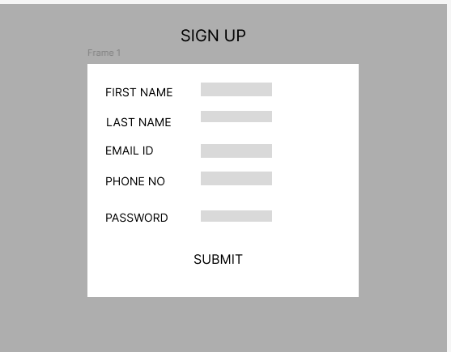

#### 7.2 Dashboard

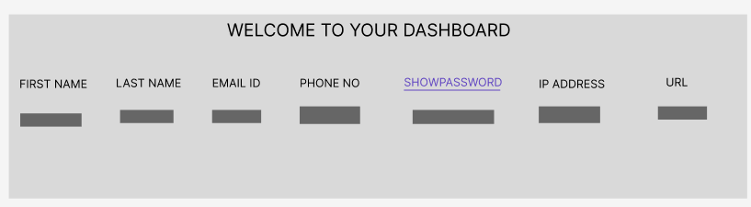

#### 8. Results

**8.1 Screenshots of Application Interfaces**

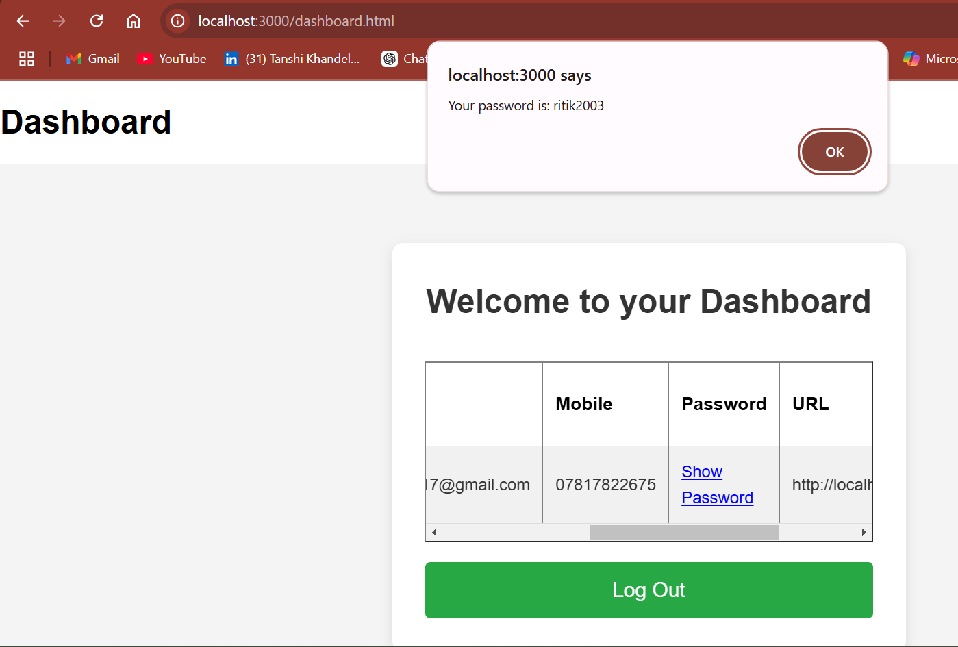

**8.2 Outputs and database content examples**

*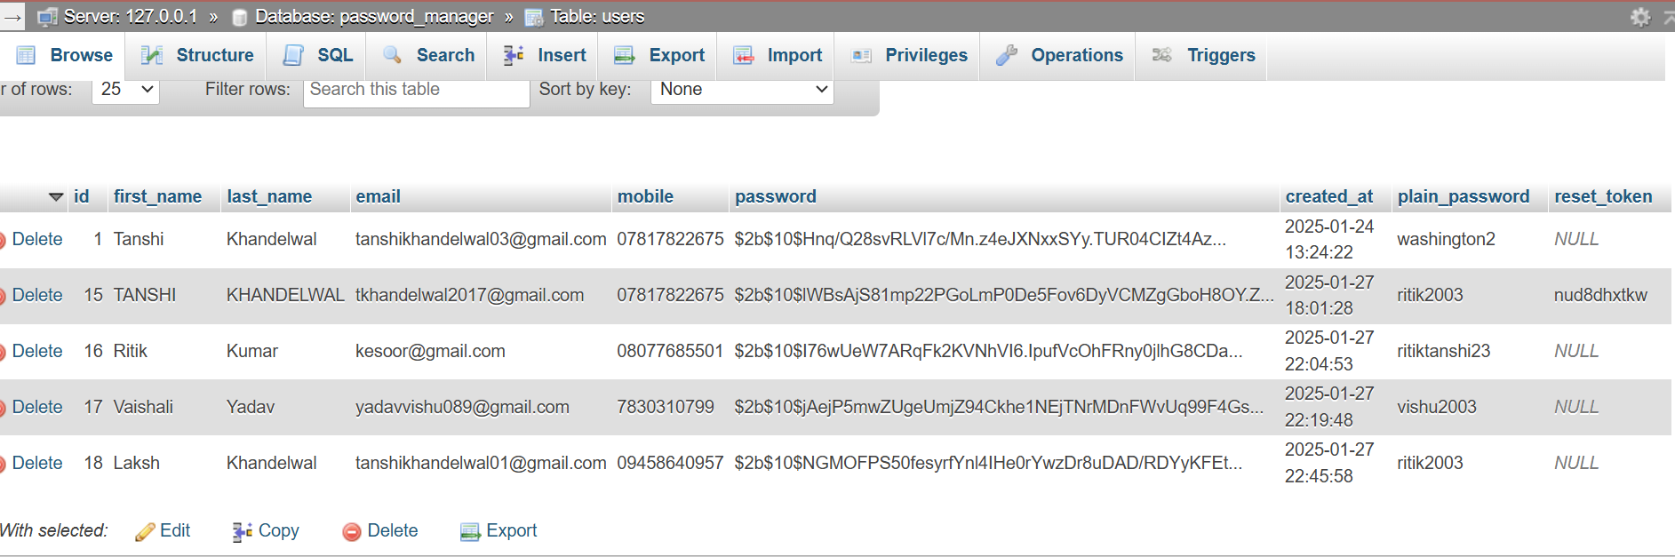***9. Future Scope**

**9.1 Enhancements for the Password Manager Project**

* **Bulk Password Generation:** Enable users to generate and store multiple passwords at once.
* **Cloud Deployment:** Deploy the application on a cloud platform for better scalability and availability.

### 10. Timeframe and Description

**10.1 Timeframe**

* **Planning:** 2 days
* **Design:** 2 days
* **Development:** 6 days
* **Testing:** 2 days
* **Deployment:** Not yet
* **Maintenance:** Ongoing

**10.2 Contribution Description**

* **Tanshi Khandelwal's Contributions:**
  + Developed the frontend, backend, and database connectivity.
  + Implemented user authentication and password management features.
  + Handled testing, debugging, documentation, and deployment.
* **Richa's Contributions:**
  + Created wireframe.

#### 11. Conclusion

The Password Manager application successfully provides a secure and centralized system for users to manage their passwords. The project demonstrates effective implementation of encryption, user authentication, and password management features. Future enhancements can further improve the functionality and usability of the application.

#### 12. References

* **Node.js Documentation:** Node.js Documentation
* **MySQL Documentation:** MySQL Documentation
* **Express.js Documentation:** Express.js Documentation
* **Node.js Tutorial:** W3Schools Node.js Tutorial
* **MySQL Tutorial:** Getting Started with MySQL
* **Express.js Tutorial:** Introduction to Express.js - W3Schools